Contents

ARM TEMPLATE 2

# ARM TEMPLATE

* An ARM (Azure Resource Manager) template is a JSON (JavaScript Object Notation) file that defines the infrastructure and configuration of Azure resources in a declarative manner.
* It allows us to define and deploy a group of resources as a single unit, known as a deployment.
* It is a common language and syntax that could be used for idempotent actions(Every ARM template can be applied multiple times, and result is always the same)

## ARM SAMPLE

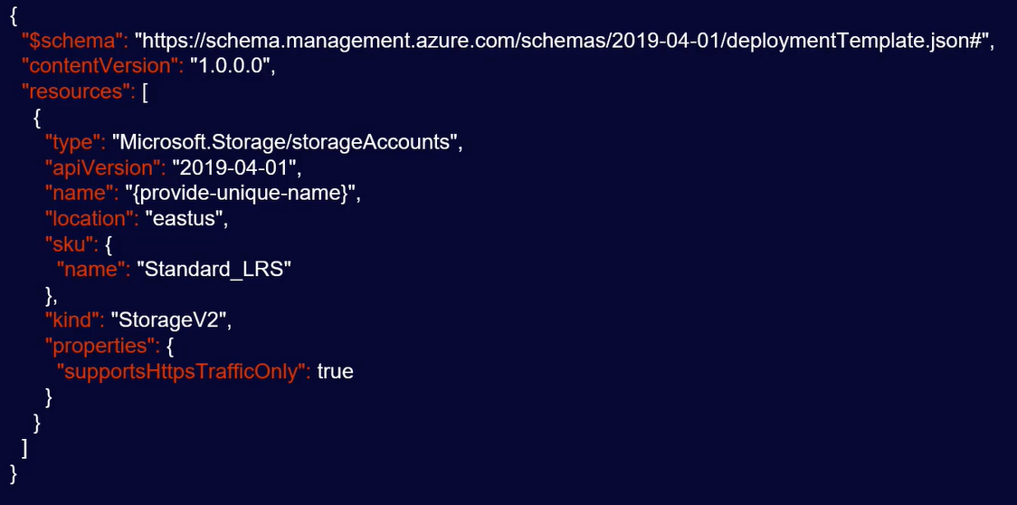

|  |  |
| --- | --- |
| **schema** | * The schema file describes the properties that are available within a template. |
| **contentVersion** | * Version of the ARM (For example, a small change might be from 1.0.0 to 1.0.1, where as a major change would go to version 2.0.0.) |
| **resources** | * What resources we want and how to manipulate them (Storage Account in above example) * This will create a storage account in the east US location of SKU type Standard LRS * {provide-unique-name} – is a variable name, which can be provided when we run the template |